
Using an electroscope

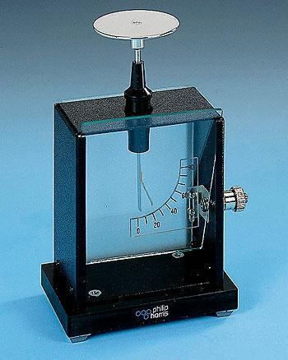
A gold-leaf electroscope measures the potential difference between the leaf and the base (or earth). The leaf rises because it is repelled by the stem (support). The leaf and its support have the same type of charge. A typical school electroscope will show a deflection for a charge as small as 0.01 pC (picocoulomb, 1x10^{–12} coulombs, equivalent to the charge on more than 6 million electrons).
Charging an electroscope
There are a number of ways to charge an electroscope. They include:
Charging by contact. Rub an insulator to charge it up. Then stroke it across the top plate of the electroscope. This will transfer charge from the insulator to the electroscope. This method is direct and clear to students. However, the charge left on the electroscope will not always leave it fully deflected.
Charging by induction. This is a quick way to get a larger charge onto the electroscope. However, it can look a bit magical to students, so it should be used with some care.
Rub an insulator to charge it up. Bring it close to the top plate of the electroscope, but don’t let it touch. This will induce the opposite charge on the plate of the electroscope, leaving a net charge on the gold leaf, which will rise. Now touch the plate with you finger momentarily to earth it (still holding the charged insulator near the top plate). The charge on the top plate will be neutralised but there will still be a charge on the gold leaf. Let go of the plate and then take the charged insulator away. The charge that had been pushed down to the gold leaf will now redistribute itself over the plate and the leaf, leaving the whole thing charged. The leaf will show a good deflection.
Charging with an EHT or Van de Graaff generator. You can use a flying lead connected to one of these high-voltage sources to charge up the gold-leaf electroscope. This is quick, effective and obvious to students. The other terminal of the supply should be earthed. Connect the flying lead to the supply through a safety resistor.
Detecting small currents
The electroscope can be used to demonstrate that a small current is flowing in a circuit (e.g. in experiments to show the ionisation of the air).
Using the hook rather than the plate makes the electroscope more sensitive to small amounts of charge. A charge of around 0.01 pC will cause a noticeable deflection of the gold leaf. Thus it is possible to watch it rise (or fall) slowly due to a current as small as 1 pA.
Put the electroscope in series (as though it were an ammeter). Any charge that flows through the circuit will move onto the electroscope, making the gold leaf rise. You may need to discharge the electroscope when you first switch on the power supply because there will be an initial movement of charge due to the capacitance in the circuit.
Alternatively, you can use the electroscope as a source of charge and watch it discharge – it is like a capacitor with its own display. Charge it up and then connect it into a circuit. If the circuit conducts, the electroscope (capacitor) will discharge and, at the same time, the leaf will display how much charge is left.
Using the electroscope as a voltmeter or electrometer
The electroscope has a very high (as good as infinite) resistance. If you earth its case, the electroscope measures potential so it is well suited to detecting potentials in electrostatic experiments. Without earthing, the quality that it measures is charge. This is related to potential difference (pd) (by its capacitance, C, i.e. V = Q/C). However, it isn’t the same as pd, because the capacitance can vary a lot – even during an experiment. Capacitance depends on the position of the electroscope, people nearby and so on.
So although the electroscope is useful as an indication of a voltage, it isn’t a reliable means of measuring it.
Cosmic radiation
School electroscopes are open to the air (more refined ones are in a vacuum). Cosmic radiation will ionise this air and cause a small leakage current, so the electroscope will discharge over time. Historically the discharging of electroscopes led to the suggestion of the existence of cosmic radiation. Victor Hess and Carl Anderson shared the Nobel Prize for Physics in 1936 for discoveries related to cosmic radiation.

